Homework 4 Report
ESAM 372-0
Rohan Krishnamurthi
11/26/2024

Part 1 – Visualizing DESeq2 Results

Case Description | Number of Differentially Expressed Genes | Total Number of Genes
6 good samples of each condition (WT, SNF2) | 547 | 7127
5 good samples of each condition, WT_21, SNF2_06 | 317 | 7127
3 lowest-number good samples of each condition | 274 | 7127
2 good samples of each condition, WT_21, SNF2_06 | 140 | 7127

Description:

Sample quality and variation in the number of replicates both have sizable impacts on the number of differentially expressed genes. Replacing the good samples with the samples SNF2_06 and WT_21 significantly reduces the number of differentially expressed genes. Additionally, lowering the number of replicates used reduces the number of differentially expressed genes to a greater extent.

Part 2 – Visualizing DESeq2 Results

Heatmap 1: top 20 genes with the greatest mean expression
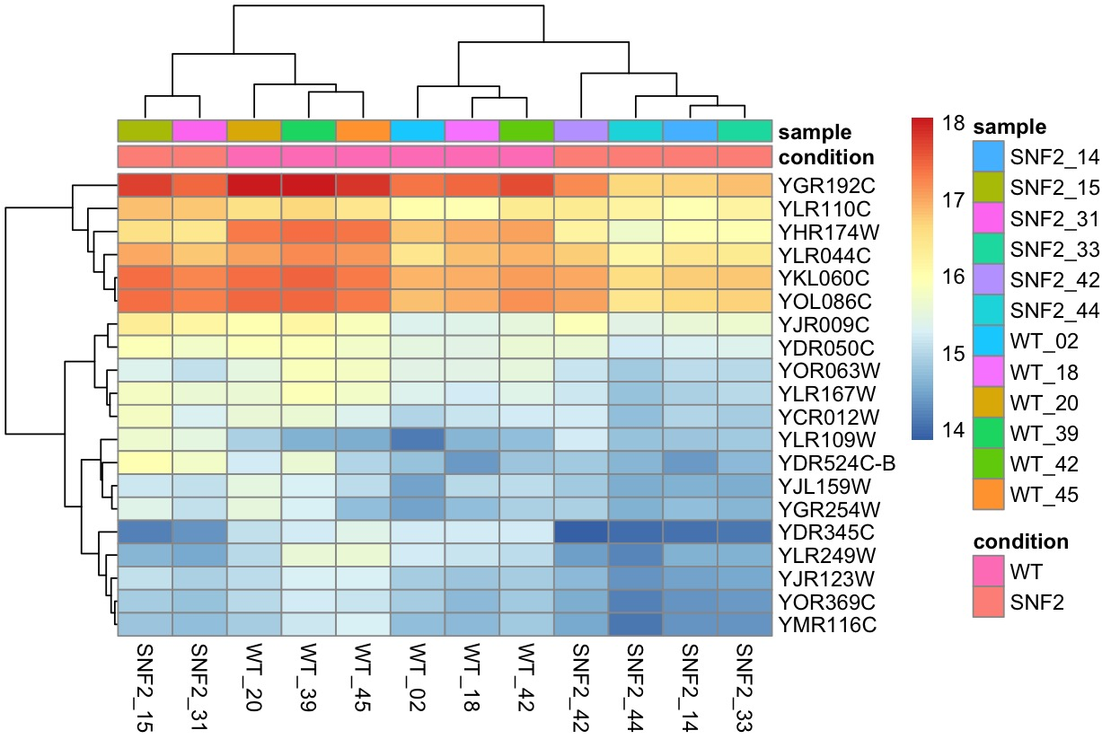

Heatmap 2: top 30 genes with the greatest mean expression
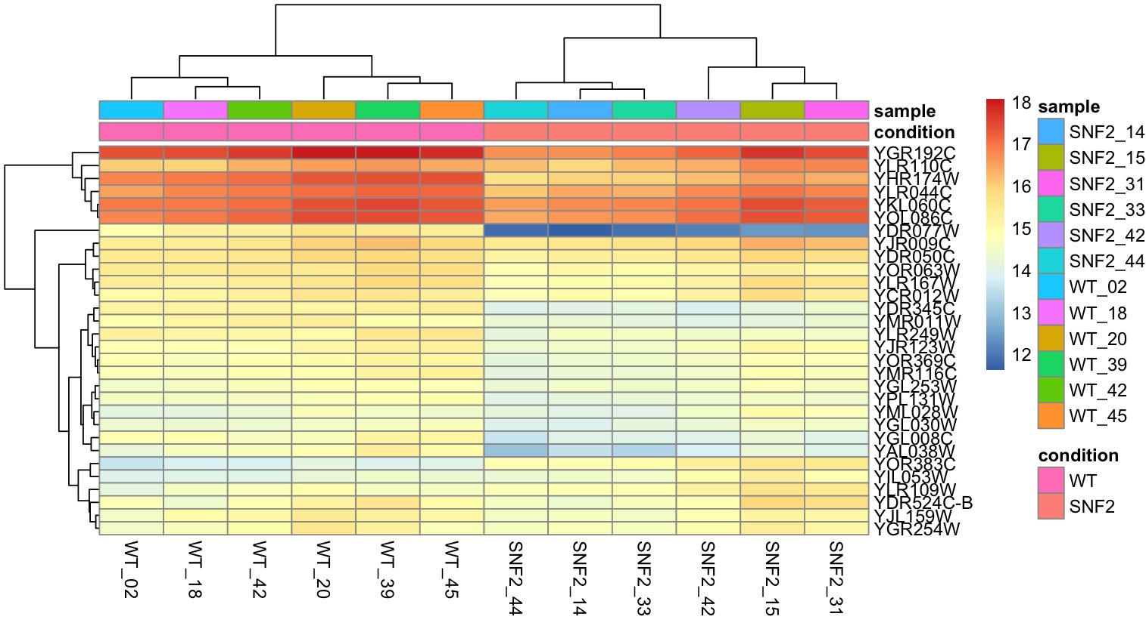

Heatmap 3: top 30 genes with the great variance
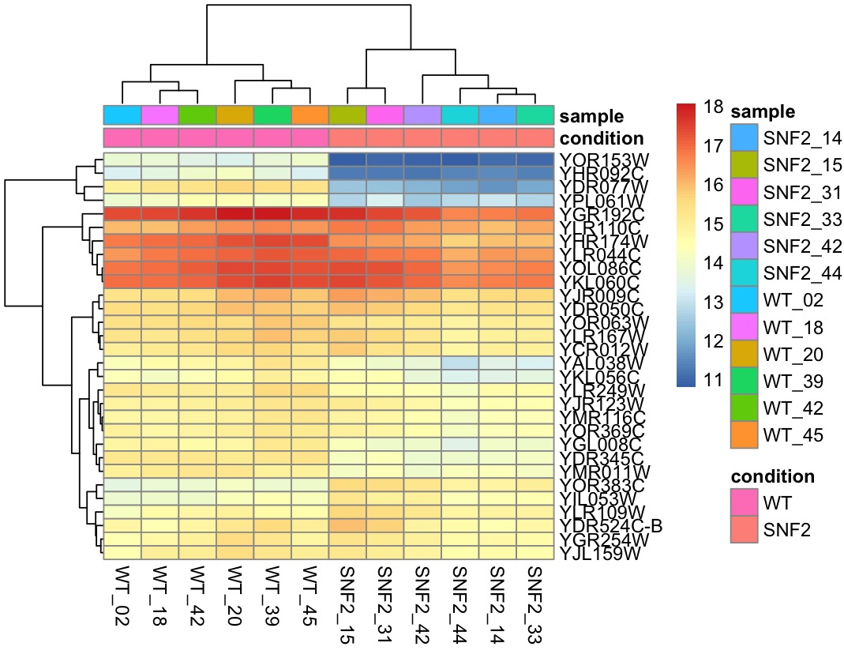

PCA 1: 500 genes with the greatest variance
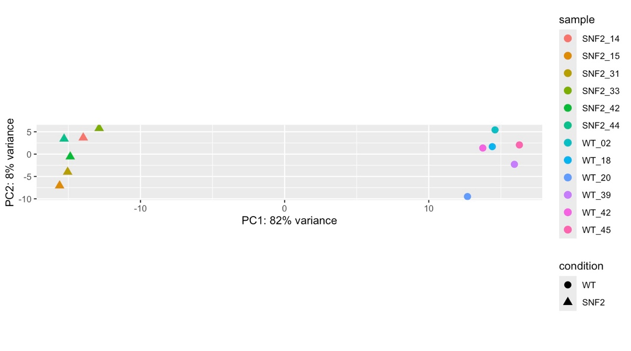

PCA 2: 5000 genes with the greatest variance
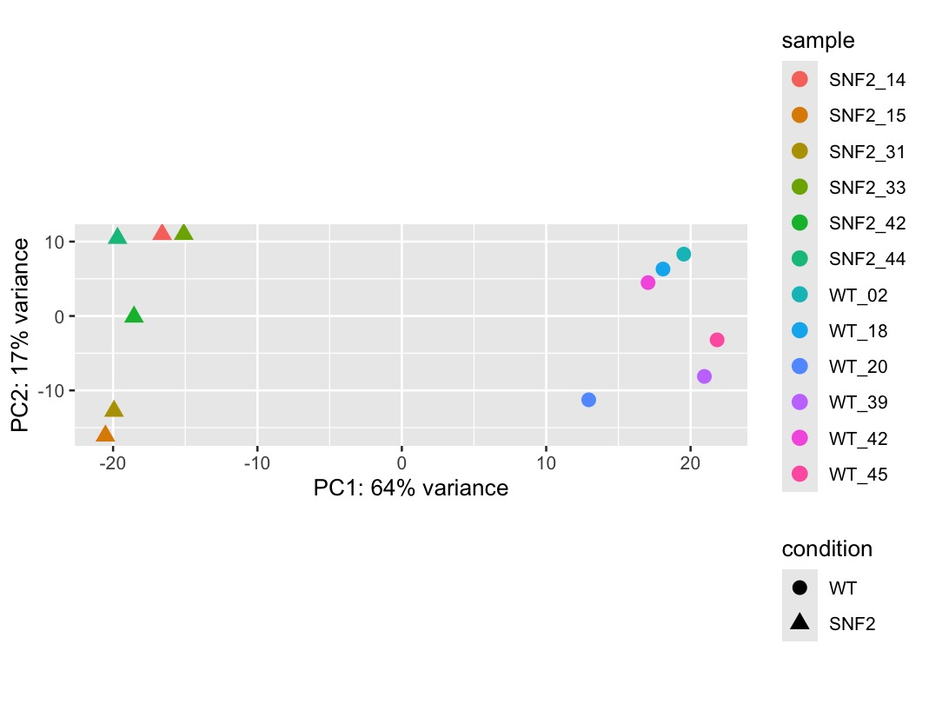

Observations:

The heatmap is moderately stable to changes in the number of genes with the greatest mean expression used. When the number of genes with the greatest mean expression increases from 20 to 30, there are minimal changes in the resulting values on the heatmap. The most notable change is that a handful of new genes exhibit lower mean expression values. Additionally, when the heatmap uses the 30 genes with the greatest variance, instead of mean expression, the heatmap is relatively unchanged as well, indicating strong stability.
PCA is significantly changed from increasing the number of genes with the greatest variance from 500 to 5000. The PC1 variance decreases from 82% to 64%, while the PC1 variance increases from 8% to 17%. Thus, the PCA is only fairly stable to changes in the number of genes with the greatest variance used.

